Title of the paper

A.N. First Author

*Institution/Company/University, City, Country, name@institution.edu*

A.N. Name, A.N. Author (from same institution)

*Institution/Company/University, City, Country, name@institution.edu, author@institution.edu*

A.N. Name

*Institution/Company/University, City, Country, name@institution.edu*

**ABSTRACT:** This template illustrates the format that must be used in the preparation of full papers for the 4th Asia-pacific Conference on Physical Modelling in Geotechnics (ACPMG 2024). Papers are to be submitted in English. All manuscripts must be prepared electronically and submitted in accordance with the following instructions using the online submission procedure of the ISSMGE Conference Review platform. Note that this text is typed in Times New Roman, size 10, justified, with the title word Abstract in bold. Abstract length should not exceed 250 words.

# guidelines

This document provides a sample paper prepared using the required format for a contribution to the 4th Asia-pacific Conference on Physical Modelling in Geotechnics.

Please read this text before you start preparing your paper for the proceedings of the ACPMG 2024. The purpose of these guidelines is to clarify a few points but also to stress that it is imperative that all authors comply exactly with the instructions and use this official template, which will be available at the ISSMGE Conference Review platform and the conference website: ([ISSMGE Conference Review Platform](https://www.issmge.org/publications/review-platform/conferences/acpmg2024)) and ([ACMPG Website](https://tc104-issmge.com/acpmg-2024/)), to ensure the highest quality and timely publication of the proceedings.

# submission AND Publication

The deadline of the submission of draft papers for review will be the 15th of June 2024. Paper submissions must include electronic versions in a Microsoft Word document (MS-docx) and an Adobe Acrobat Portable Document Format (PDF). The proceedings will be published in digital format only.

Submitted papers should be 2 to 6 pages long, including tables, figures, acknowledgements, references, etc.

The papers will be published in digital format only. Papers will be published in Open Access in the ISSMGE Online Library and will be sent to indexing services such as Scopus, WoS/Clarivate, EI, and Compendex.

## Language

The paper must be written in English.

The paper is expected to be submitted in this format, with all the usual elements of a self-contained scientific or technical paper. It should comply in terms of structure and layout with the instructions given below.

## Material

Contributions are accepted on the understanding that the paper is original and has not been published before.

## Text format

Please note that the layout of all sections that appear after the abstract must be in a double-column format. This means that only the double column layout is acceptable for publication. The two columns of text on the last page of each paper must be balanced (that is, adjusted to have the same vertical extent; use the column break to achieve this).

Do not change the margin settings or page dimensions within the template. These are as follows:

* Paper size ISO A4 (210 x 297 mm)
* Top: 2.8 cm
* Bottom: 2.2 cm
* Left: 2.0 cm
* Right: 2.0 cm

## Structure

Please adhere to the following order of presentation: Title, Author(s), Affiliation(s), Abstract, Main text, Conclusions, Acknowledgements and References.

The title should be written as a sentence, so NO capital letters where they would not usually appear. And no full stop (“.”) at the end of the title.

For example: Remote sensing for monitoring the changing landscapes (Not: Remote Sensing for Monitoring the Changing Landscapes).

### Author(s)

Author should start with the Initial(s) and then the Family name. For example: I. Newton, J. Lewis & A.N. de Groot.

### Titles

Titles or occupation (such as Prof., dr., eng. PhD etc) are NOT permitted in the list of authors.

### Abstract

The abstract should be readily understandable to most readers and may contain up to 250 words. Use the full type-width of the page (single column).

## Text

The typesetting should be Times New Roman 11 pt for the abstract and the body of the text. The paragraph indent must be 0.5 cm, except for the first paragraph, which should be 0 cm. The text for the References section should be in Times New Roman 10 pt. Symbols should be in *italics* and SI (international system) units must be used throughout the whole text.

For the text, a maximum of three levels of sections and subsections is allowed.

## Headings

Headings 1 and 2 should be in 12 pt Times New Roman, only capital letters for heading level 1. It is important to reproduce the spacing of the text and headings as shown here. Text should be single spaced.

## Figures

Figures and images can be either in colour, grayscale or black and white. Both images (captured by camera or rendered by computer) and figures (graphs, diagrams, etc.) are referred to as figures and are numbered consecutively. Figures are allowed to fill either one or two columns and must be accompanied by a caption below. Be sure to have a *page break* before a two-columns figure, as shown in this template file. This way, the heading above the page (author names or running title) remains correct.

Do not create any line drawings in the article, as figures assembled from Word object may fall apart during formatting and printing. If you wish to use figures assembled using MS Word drawing objects, please prepare it in a separate file and copy it into the final article as a single image.

It is essential that the bitmap images have sufﬁcient resolution to allow faithful reproduction.

Figures should not have extra white borders and must be properly cropped.



Figure 1. View of the Sheikh Zayed Grand Mosque in Abu Dhabi.

## Tables

Tables follow the instructions for figures, with the addition that the headers should be in bold.

The reference to figures and tables should be as Figure 1 and Table 1, respectively. Figures and tables should be numbered consecutively.

Table 1. Use 10 pt both in the headers and the text of Tables.

|  |  |  |
| --- | --- | --- |
| Header | Sub 1.1 | Sub 1.2 |
| Sub 2.1 | 1 | 4 |
| Sub 2.1 | 2 | 5 |
| Sub 2.1 | 3 | 5 |

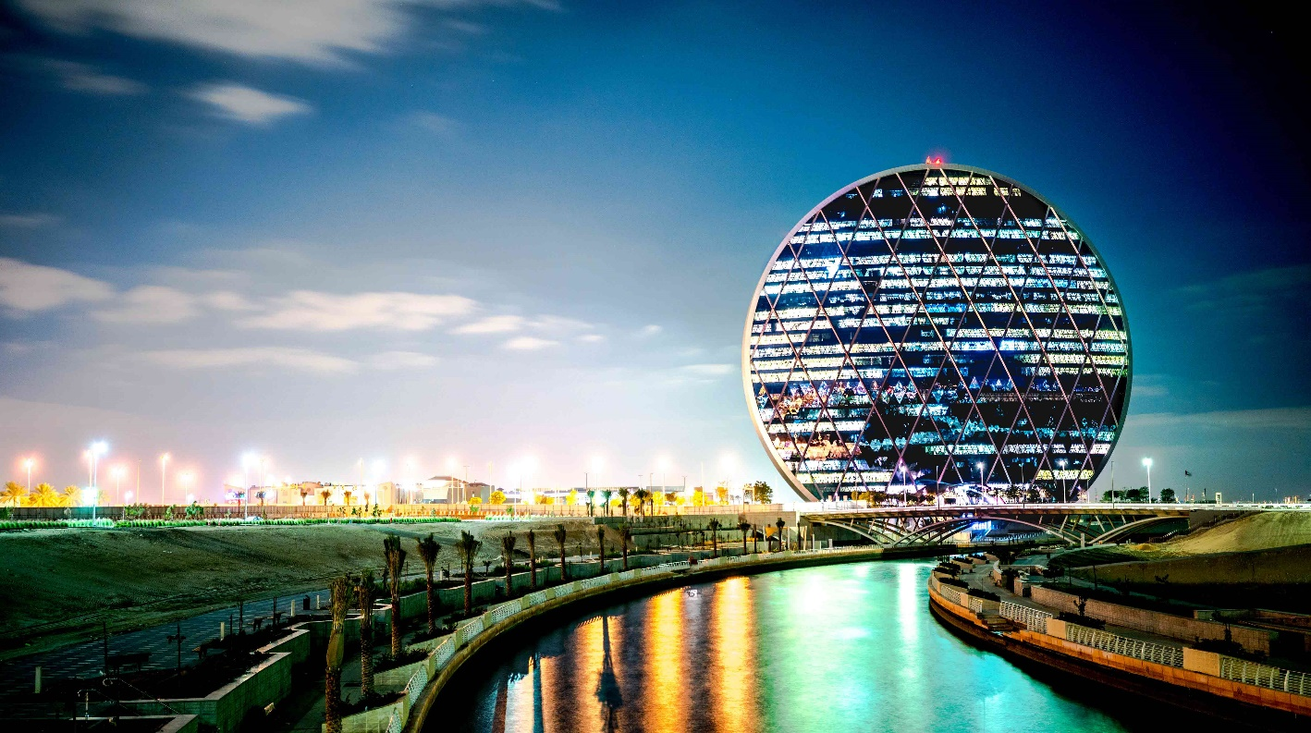

Figure 2. Figures and tables can fill either one or two columns.

## Equations

Samples of equations are given in this section and each equation should be numbered consecutively. Refer to equations by these numbers.

Equations should be written using the equation editor of Word and the font size 12 pt. The layout should be standard "professional".

All symbols should be in italics. Indent is 0.5 cm for equations and an empty line must be placed above and below equations.

The used parameters must be described below the equations, and units should be given in parentheses.

$e^{z}=q^{'}∙K_{q}^{z}+c∙K_{c}^{z}$ (1)

$K_{q}^{z}=\frac{{K_{q}^{0}+K_{q}^{∞}∙α}_{q}∙\frac{z}{B}}{1+α_{q}∙\frac{z}{B}}$ (2)

$α_{q}=\frac{K_{q}^{0}}{K_{q}^{∞}-K_{q}^{0}}∙\frac{K_{0}∙sin}{sin\left(45+0.5∙\right)}$ (3)

where $e^{z}$ (kPa) is the earth pressure at depth *z* (m), etc.

# References format

## Referencing guidelines

References should be made to the latest literature and, whenever possible, to well-respected scientific journals that are relevant in the field. References should be given with precise data to help the reader finding them, including volume and page numbers. DOI numbers must also be given when available, for journal articles, books, conference papers. The link on the DOI should be clickable (for example, [http://doi.org/[DOI](http://doi.org/%5BDOI)]).

In order to find Digital Object Identifiers (DOIs) for journal articles cited in your manuscript, use the page:

<http://www.crossref.org/SimpleTextQuery/>

The list of references should be arranged in alphabetical order, using Times New Roman, 10pt size, hanging of 0.5 cm.

The in-text citation style is as follows:

* cite references in the text using the author’s last name and date of publication, e.g., (Jenkins, 1980), (Jenkins and Smith, 1980), or (de Groot et al., 1980);
* when there is no editor, translator, or author, use the article title with the date, i.e., Non-Standard Cylindrical Gears (2002);
* for multiple citations, use the following notation when citing in the text: (Jenkins, 1980, 1989) for two references by the same author; (Jenkins, 1980a, 1980b) when both references were published in the same year by the same author or authors.

For preparing the References list, consider the following guidelines:

* use complete last (family) names for authors but use initials for first and middle names.
* web references must contain the title of the site and the URL. Also include the author, the date the information on the site was written or accessed.
* to add DOIs to any reference type, insert a period at the end of the reference, and the DOI link as http://doi.org/[DOI], without a period at the end.
* please note the organization of author names in the references (Author1 Last name, initials of Author1, initials of Author2, Author2 last name, and initials of Author3, Author3 last name.
* for cited papers not in English, give the title in original language, then the translation to English, and a remark at the end: (in [Language]).
* Please note that all references listed here must be directly cited in the body of the text.

# Conclusions

Conclusions should state concisely the most important propositions of the paper as well as the author’s views of the practical implications of the results. Although a conclusion may review the main points of the paper, do not replicate the abstract as the conclusion. A conclusion might elaborate on the importance of the work or suggest applications, extensions, and future developments.

# ACKNOWLEDGEMENTS

The authors are grateful for the financial support provided by funding agency XXX. The project presented in this paper is supported by YYY.

# References

Bermingham, P. and Janes, M.C. (1989). An innovative approach to load testing of high capacity piles. *Proceedings of the International Conference on Piling and Deep Foundations*, J. B. Burland and J. M. Mitchell (eds.), Balkeman, Vol. 1, pp. 409-413.

Boulanger R.W. and Idriss I.M. (2014). CPT and SPT based liquefaction triggering procedures. Report No. UCD/CGM-14/01. Center for Geotechnical Modeling, University of California, Davis.

NSSGA (2013). *The Aggregates Handbook*, 2nd ed., National Stone, Sand, and Gravel Association. Alexandria, Virginia.

Oden, C. P., Ho, C. L. and Kashani, H. F. (2018). Man-Portable Real-Time Ballast Inspection Device Using Ground-Penetrating Radar. In *Railroad Ballast Testing and Properties*, T. Stark, Swan, R. and Szecsy, R. (eds.), pp. 77–104. West Conshohocken, PA: ASTM International. <http://doi.org/10.1520/STP160520170023>

Skempton, A. W. (1970). First-time slides in over-consolidated clays. *Géotechnique*, 20(3): 320-324. <https://doi.org/10.1680/geot.1970.20.3.320>

Terzaghi, K. (1943). *Theoretical Soil Mechanics.* John Wiley & Sons.

Wood, J.H. (1973). *Earthquake-Induced Soil Pressures on Structures*. PhD thesis, California Institute of Technology, Pasadena, CA.